
SCHOOL OF COMPUTING AND ENGINEERING SCIENCES (SCES)
BACHELOR OF SCIENCE IN ELECTRICAL AND ELECTRONICS
ENGINEERING (BSEEE)
CONTROL SYSTEMS 2
Lab 3:
DETERMINING THE ROBOT CAR MODEL PARAMETERS

BY
Edward Mwongela
(GROUP 5)

Lecturer: Prof. Jackson Mbuthia
29th October 2024

Table of Contents
List of figures 2
1. Title: 3
2. Objective: 3
3. Learning Outcome: 3
4. Homework to be done as group work. 4
I. Introduction 4
II. Experimental Design – Determining the Robot Car Model Parameters 6
Robot car wheel speed measurement 6
Current and Voltage Measurement 9

List of figures
Figure 1. Brushless DC Motor – 3 Phase Star Connected Armature (Stator or Rotor) 4
Figure 2. Electronic Speed Controller 4
Figure 3. Motor-ESC Wiring Diagram 5
Figure 4. Robot car - BLDC Motor 6

1. Title:
Determining the Robot Car Model Parameters

2. Objective:
- Use a simple optical sensor to measure the rotational angular velocity of a Robot car wheel
- Measure the Robot car BLDC Motor winding resistance, rated current and power.
- Measure the Robot Car Motor Acceleration – Off Road
- Measure the Robot Car Acceleration – On Road
- Plot the Robot car speed (m/s) v(t) vs time to determine the transfer function

3. Learning Outcome:

- Apply an experimental procedure to determine BLDC motor and electronic speed controller (ESC) parameters
- Use the measured BLDC motor and ESC parameters to derive the Robot car drive system transfer function.

4. Homework to be done as group work.

Introduction
The Robot car uses 2 brushless motors shown in Fig. 1 to drive 2 front wheels and 2
Electronic Speed Controllers (ESC) are shown in Fig. 2 to drive the front wheels. The back
wheels are assembled to allow free movement.
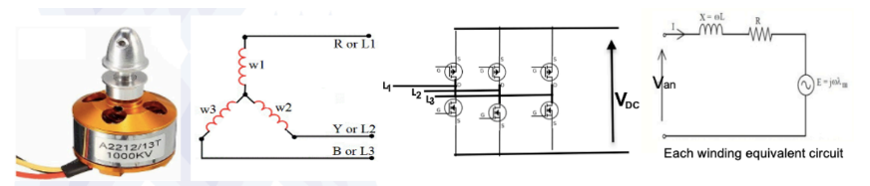
Figure 1. Brushless DC Motor – 3 Phase Star Connected Armature (Stator or Rotor)

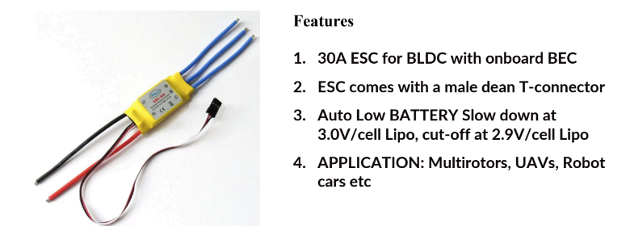
Figure 2. Electronic Speed Controller
The motor shown in Fig. 1 has a maximum speed of 1000Kv * DC Supply Voltage. To obtain optimum torque over a wide speed range when using the ESC, it is necessary to have one ratio gear to reduce the maximum wheel speed to a third of the maximum BLDC motor speed. This will produce an equivalent maximum Robot car wheel speed of approximately 11 m/s. The motor has three input wires to supply three windings connected in star configuration as shown in Fig. 1. The ESC is a motor driver that produces a variable voltage to supply the motor. A PWM pulse is used to control the motor windings voltage Van rms value and frequency to produce variable wheel thrust/speed and to implement control concepts generated from code which is run on a microcontroller. The Motor-ESC wiring diagram is shown in Fig. 3
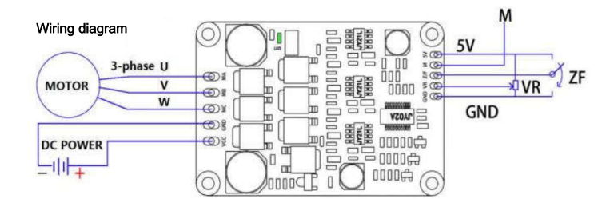
Figure 3. Motor-ESC Wiring Diagram
5V- Driver board internal output voltage
M - Motor speed pulse signal output, 5V pulse signal.
(i) Control port
Z/F- Rotating direction control ports. Connect “5V” high level or no connect is Forward direction, connect 0 V low level or connect to GND is reverse direction VR ----Speed/thrust control port. Analog voltage linear speed regulation 0.1v-5V. The input resistance is 20K Ohm, connect with GND for input PWM speed regulation,
PWM frequency:1-20KHZ;
Duty cycle 0-100% GND—Used for Drive board internal control.
(ii) Power port
MA - motor phase A
MB - motor phase B
MC - motor phase C
GND - DC-
VCC - DC +

Experimental Design – Determining the Robot Car Model Parameters
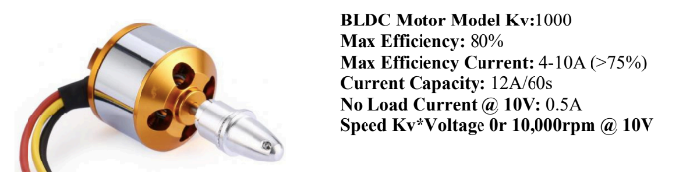
Figure 4. Robot car - BLDC Motor

Robot car wheel speed measurement
  - Explain how you can use a simple optical sensor to measure the rotational angular velocity of the Robot car wheel. Write an Arduino program to measure and calculate the motor speed.
  - Procedure:
- Set Up the Motor and Slotted Wheel - Connect the BLDC Motor: Wire the BLDC motor to a suitable driver circuit to allow reliable and stable rotation.
- Attach the Slotted Wheel - Using a folded piece of paper or similar material, increase the diameter of the BLDC motor shaft so that a slotted wheel can be attached securely. This wheel will create interruptions (or pulses) as it rotates, which will be detected by the optical sensor.
- Position the LM393 Optical Sensor - Set Up the Sensor with a Clamp: Attach the LM393 optical sensor to a clamp stand and position it such that the slotted wheel rotates between the sensor’s light emitter and detector without touching them.
- Align the Slotted Wheel and Sensor - Adjust the alignment so that each slot on the wheel passes cleanly through the sensor's path, allowing the LM393 to detect each slot as it interrupts the light.
- Connect the LM393 to the Arduino - Connect the output of the LM393 sensor to a digital input pin on the Arduino (e.g., pin 2). Make sure the sensor is also connected to the Arduino’s ground (GND) and 5V power supply for proper operation.
- Upload the Code to the Arduino - Upload a program to the Arduino that counts the pulses generated by the LM393 sensor as each slot passes through the light beam. This code should: Count each pulse, which corresponds to a slot in the slotted wheel. Use the counted pulses over a known time interval to calculate the rotational speed (in RPM or rad/s).
- Observe the Serial Monitor - Open the Serial Monitor on the Arduino IDE to see the speed readings. These readings represent the rotational angular velocity of the wheel.
  - Code:
//LM393
const int sensorPin = 2; // Connect LM393 output to digital pin 9
int sensorValue = 0;
int lastSensorValue = 0;
float rpm = 0;
float counter = 0; // Declare the counter variable
int second = 1;
unsigned long previousMillis = 0;
const int sampleInterval = 50; // Time interval (in milliseconds) between RPM calculations
float metres = 0.07854; // Distance moved per metre
float vel = 0;
unsigned long currentTime = 0;
unsigned long currentMillis = 0;
//ESC
#include <Servo.h>
Servo ESC; // create servo object to control the ESC
int escValue; // value to control the ESC
void setup() {
ESC.attach(9, 1000, 2000); // Attach the ESC on pin 9, with min and max pulse widths
// Send minimum throttle (or below minimum to make sure ESC recognizes zero throttle)
ESC.write(0);
delay(1000); // Wait for the ESC to recognize minimum throttle
// Send minimum throttle again to arm the ESC
ESC.write(0);
delay(1000); // Wait for the ESC to arm
//LM393
pinMode(sensorPin, INPUT);
Serial.begin(115200);
}
void loop() {
escValue = 180 ; // Set a fixed value between 0 and 180 (90 is typically the midpoint)
if (escValue > 0){
measure();
ESC.write(escValue); // Send the signal to the ESC
}
}
//LM393
void measure() {
sensorValue = digitalRead(sensorPin);
if (sensorValue != lastSensorValue) {
counter++;
currentMillis = millis() - currentTime;
if (currentMillis - previousMillis >= sampleInterval) {
rpm = ((counter * 50) / currentMillis);
previousMillis = currentMillis;
vel = (rpm * metres);
}
lastSensorValue = sensorValue;
}
if (currentMillis >= 100) {
Serial.print("Speed: ");
Serial.print(vel, 3);
Serial.println(" m/s");
counter = 0;
second = 1;
previousMillis = 0;
currentTime = millis();
currentMillis = 0;
}
}
  - Measure the Robot car BLDC Motor winding resistance, rated current, power and torque.

Current and Voltage Measurement
Explain how you can use a Hall Effect module and ADCs to measure the motor winding Current and Voltage so that you can calculate the motor power and torque. Write an Arduino program to measure and calculate the motor winding current, power and torque.

Using a Hall Effect module in conjunction with an ADC (like an Arduino) allows you to measure the motor winding current and voltage which you can then use to calculate the motor power and torque. Below is a comprehensive guide on how to set this up, including a sample Arduino code.
  - Components
Hall Effect Sensor: Used to measure the motor current. In this case, the ESC (Electronic Speed Controller) provided will typically have a built-in Hall Effect sensor for current measurement.
Arduino: Acts as the ADC, converting analog signals from the sensors into digital values for processing.
BLDC Motor: The motor you are measuring.
Wiring and Connections: Jumper wires to connect all components.
  - Setup Procedure
Connections: Connect the ESC to the BLDC motor according to the manufacturer's instructions. Connect the ESC’s current and voltage outputs to the Arduino’s analog pins (e.g., A0 for current and A1 for voltage). Ensure that the ESC is powered correctly and the Arduino is connected to your computer for programming and monitoring.
  - Code:
const int currentSensorPin = A0; // Pin for current sensor (ACS712)
const int voltageSensorPin = A1; // Pin for voltage sensor (voltage divider)

// Motor parameters
const float Kv = 1000; // Motor Kv rating (RPM per Volt)
const float maxEfficiencyCurrent = 10.0; // Maximum efficiency current in Amps
const float noLoadCurrent = 0.5; // No-load current at 10V
const float torqueConstant = 9.5488 / Kv; // Torque constant in Nm per Amp

// Calibration factors for the current sensor (ACS712)
const float currentSensorOffset = 2.5; // Offset voltage of the current sensor at 0A
const float currentSensorSensitivity = 0.185; // Sensitivity of ACS712 (e.g., 185 mV per Amp)

// Voltage divider ratio
const float voltageDividerRatio = 11.0; // Ratio for a 10k/1k divider

void setup() {
Serial.begin(9600);
pinMode(currentSensorPin, INPUT);
pinMode(voltageSensorPin, INPUT);
}

void loop() {
// Measure and calculate current
float currentVoltage = analogRead(currentSensorPin) * (5.0 / 1023.0); // ADC to voltage
float motorCurrent = (currentVoltage - currentSensorOffset) / currentSensorSensitivity; // Convert to Amps

// Measure and calculate voltage (Van)
float voltageReading = analogRead(voltageSensorPin) * (5.0 / 1023.0); // ADC to voltage
float motorVoltage = voltageReading * voltageDividerRatio; // Adjust for divider ratio

// Calculate motor RPM
float motorRPM = Kv * motorVoltage;

// Calculate motor power
float motorPower = motorVoltage * motorCurrent; // Power in watts

// Calculate motor torque using torque constant
float motorTorque = (motorCurrent - noLoadCurrent) * torqueConstant; // Torque in Nm

// Display the results
Serial.print("Motor Voltage: ");
Serial.print(motorVoltage);
Serial.print(" V, Motor Current: ");
Serial.print(motorCurrent);
Serial.print(" A, Motor Power: ");
Serial.print(motorPower);
Serial.print(" W, Motor Torque: ");
Serial.print(motorTorque);
Serial.print(" Nm, Motor RPM: ");
Serial.print(motorRPM);
Serial.println(" RPM");

delay(2000); // Delay for 2 seconds between readings
}

